

Experiment No. 8

Title: Password Cracking - Burp suite, Cain and Abel

**Batch: B2 Roll No.: 16010420117 Experiment No.: 8**

**Aim:** To implement password cracking using Burp suite and Cain and Abel

**Resources needed:** Burp suite Professional, Cain Abel open source tool

# Theory

**Procedure / Approach /Algorithm / Activity Diagram:**

# Implementation:

Task1: Explain dictionary attack step by step using Burp Suite (Including screen shots)

Task2: Explore any web exploit step by step using Cain Abel (Including screen shots)

**Questions:**

1) What is the difference between Burp suite and open source Cain Abel?

(Justify your answer with features).

Ans: Burp or Burp Suite is a set of tools used for penetration testing of web applications while cain abel is password recovery tool.

**Result:** Screenshots of task 1 and 2 demonstrating the activity**.**

Open Burp Suite and start proxy:

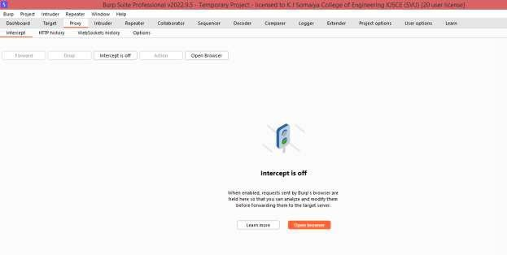

Used test website :<http://altoro.testfire.net/login.jsp>to perform dictionary attack using burp suite

Intercept form submission packet and send to intruder

Chosen attack type cluster bomb:

Added payload markers to username and password

Added Payloads

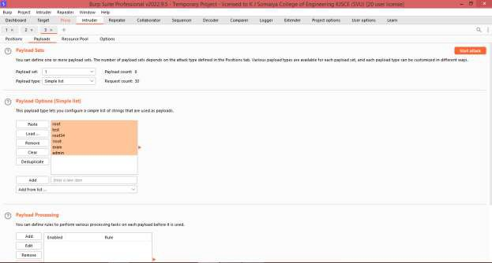

Started attack

Attack successful

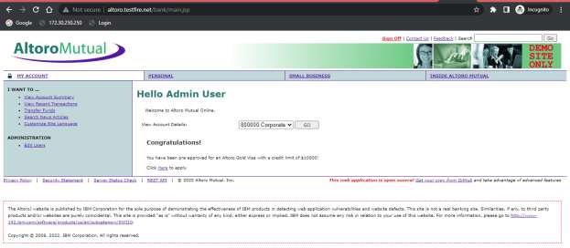

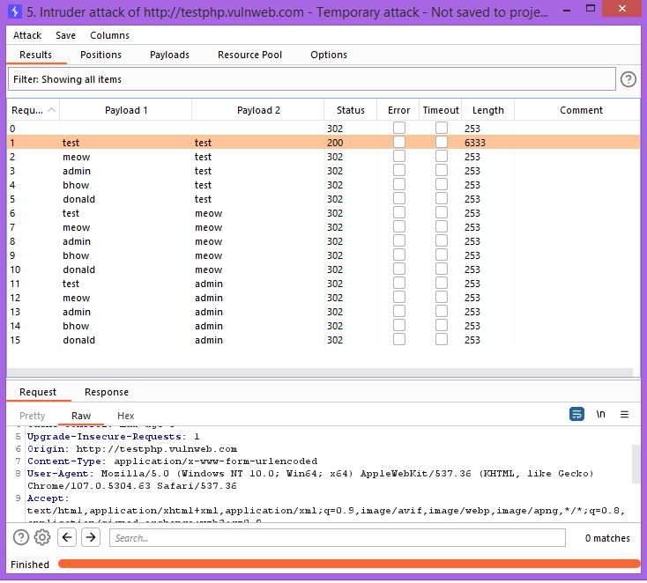

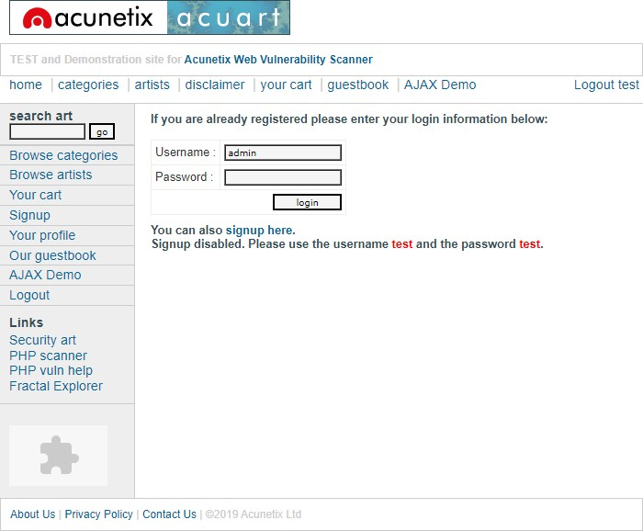

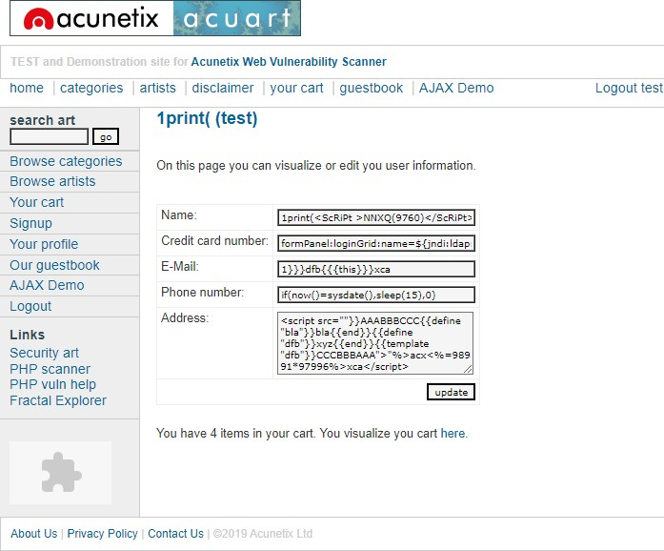

**Outcomes:** CO4: Understand Security issues related to Software, Web and Networks.

**Conclusion: (**Conclusion to be based on the objectives and outcomes achieved**)** Attacks using burpsuit is implemented successfully.

________________________________________________________________________________________________________________________________________________________________________________________________________________________________________________________________________________________________________________________________________________________________________________________________________________________________________________________

**Grade: AA / AB / BB / BC / CC / CD /DD**

**Signature of faculty in-charge with date**

**_______________________________________________________________________________________**

**References:**

**Books/ Journals/ Websites:**

1. [**https://en.wikipedia.org/wiki/Cain_and_Abel_(software)**](https://en.wikipedia.org/wiki/Cain_and_Abel_(software))
2. [**https://www.darknet.org.uk/2007/01/cain-and-abel-download-windows-password-cracker/**](https://www.darknet.org.uk/2007/01/cain-and-abel-download-windows-password-cracker/)
3. [**https://sectools.org/tool/cain/**](https://sectools.org/tool/cain/)
4. [**https://portswigger.net/burp/pro**](https://portswigger.net/burp/pro)